Homework #2

20181283 HWANG GYOHUN(황교훈)

Environment

* hardware
  + iMac (Retina 5K, 27-inch, 2020)
  + processor : 3.1 GHz 6 core Intel Core i5
  + memory : 8GB 2667 MHz DDR4
  + graphic : AMD radeon Pro 5300 4 GB
* operating system
  + macOS
* used libraries
  + netdb.h
    - for using hostent for hostname to address
  + arpa/inet.h
    - for using inet_addr / inet_ntoa
  + sys/socket.h, sys/types.h
    - for using many kinds of operands like accept(), bind(), etc.
  + netinet/in.h
    - for using sockaddr_in struct
  + stdio.h
  + string.h
    - for using strlen, memset

Compilation commands(If needed)

* I make Makefile which is like below

proxy : main.o

gcc -o proxy main.o

main.o : main.c

gcc -c -w -o main.o main.c

clean :

rm *.o *.html proxy

And it also is hw2.zip

So in terminal, Just make temp make proxy file

And ./proxy <port number> then it work

In another terminal, run telnet localhost <port number>, which is used for ./proxy <port number>

If there is some issue that prints some errors in the terminal, then you must use another port number.

If you want to remove the proxy executable file, then just write make clean in the terminal.

Implementation details

* In my implement, order is like below

1. socket() proxy server socket
2. bind proxy server
3. listen proxy server
4. accept the client
5. receive socket from client
6. check input is valid
7. if valid
   1. make input as the format to send to the origin server
   2. get server
   3. socket which will send to server
   4. connect to server
   5. receive socket from server
   6. write to client the data
8. else write data which implies Not implemented or Bad request

Result

like the right terminal, Just ./proxy <port number>.

If proper input telnet in the left terminal, that returns the data like below.

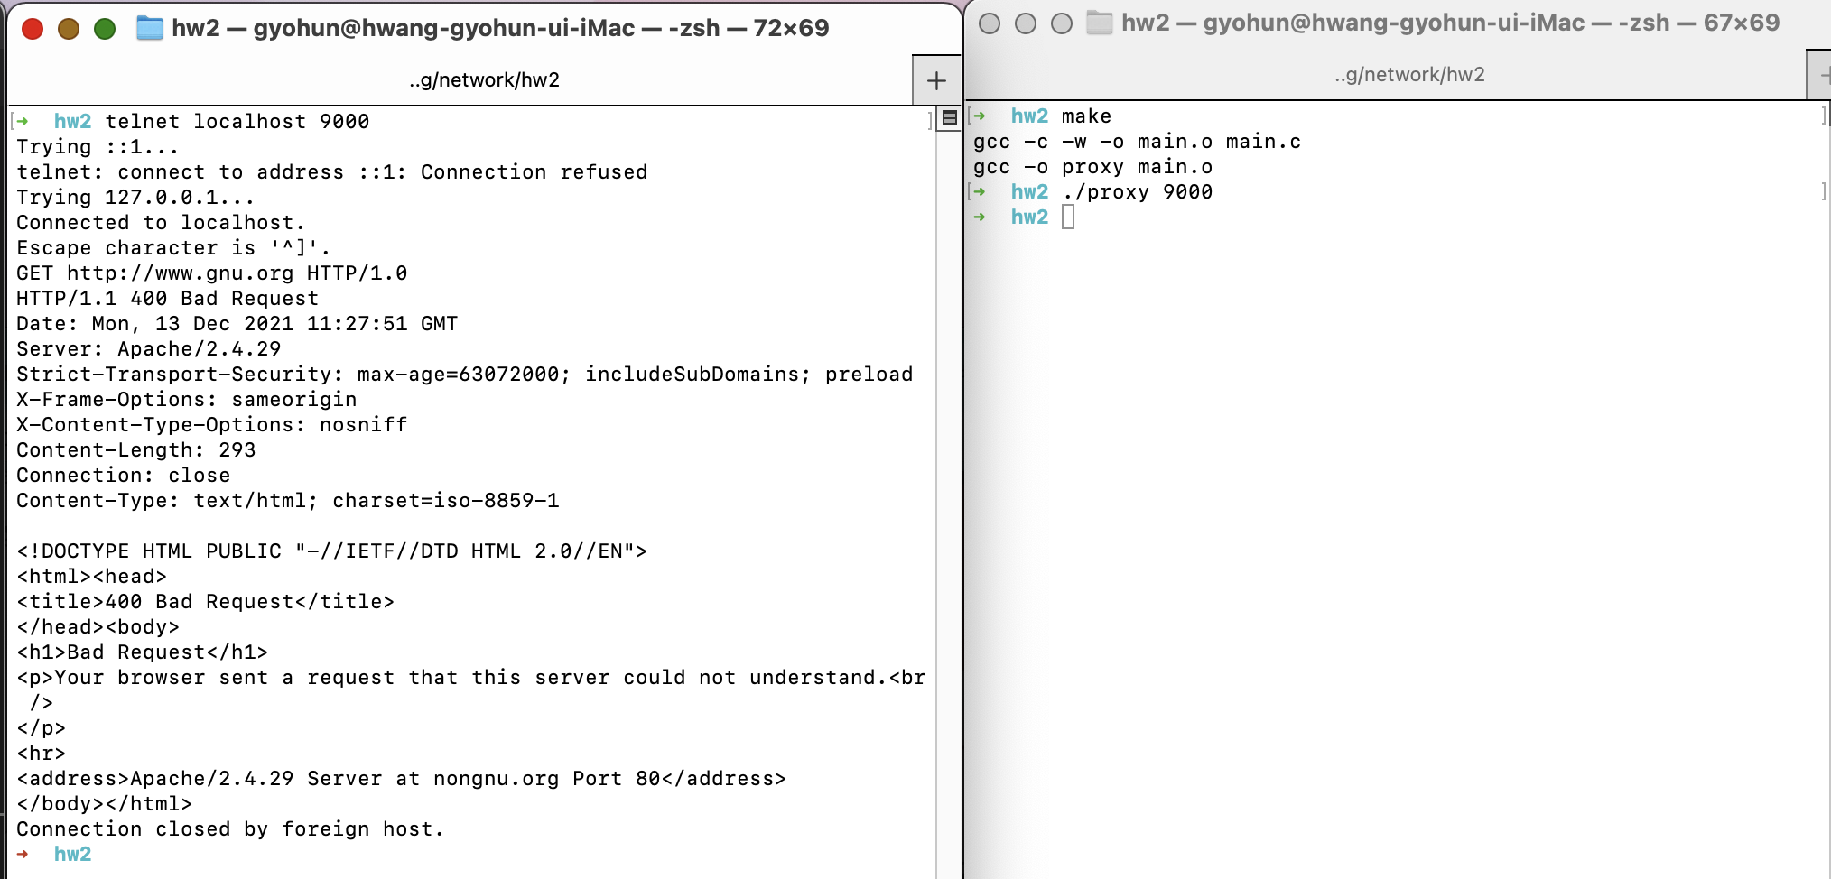

And if inapposite input, then return Bad Request(400) or Not Implemented(501) like below.

